**Modern HTML Assignment**

**Q1) list out the features of HTML5.**

* a)Audio and video : Audio and Video tags are the two major addition to HTML5. It allows developers to embed a video or audio on their website. HTML5 video can use CSS and CSS3 to style the video tag. You can change the border, opacity, reflections, gradients, transitions, transformations, and even animations. HTML5 makes adding video super-fast and without having to build a video player.
* b)Vector Graphics: This is a new addition to the revised version which has hugely impacted the use of Adobe Flash in websites. It can be used to draw graphics with various shapes and colors via scripting usually JS. Vector graphics are scalable, easy to create and edit. It also supports interactivity and animation.
* c)Header and footer: With these new tags, there is no longer a need to identify the two elements with a <div> tag. Footer is placed at the end of the web page while Header is placed at the start of the web page. By using <header> and <footer> HTML5 elements, the browser will know what to load first and what to load later.

The header can contain-

* One or more heading elements (<h1> – <h6>)
* Logo or icon
* Authorship information

Footer can contain-

* Authorship information
* Copyright information
* Contact information
* Back to top links

d)Figure and ficaption: HTML5 allows to use a <figure> element to mark up a photo in a document, and a <figcaption> element to define a caption for the photo. The <figcaption> tag defines a caption for a <figure> element. This tag provides a container for content that is equivalent to a figure. It can be used to group a caption with one or more images, a block of code, or other content.

e)Nav Tag: The <nav> tag defines a set of navigation links. It is used for the part of an internet site that links to different pages at the website. The hyperlinks can be organized through a number of approaches. Common examples of the nav elements are menus, tables, contents, and indexes. This element makes it much easier to create a navigation menu, creates a neat horizontal menu of text links, and helps screen reading software to correctly identify primary navigation areas in the document.

f)Progress Tag: The progress tag is used to check the progress of a task during the execution. Progress tag can be used with the conjunction of JavaScript.

g)Placeholder Attribute: The placeholder attribute specifies a short hint that describes the expected value of an input field/text area. The short hint is displayed in the field before the user enters a value.

h)Email Attribute: When the input type in the form set as email, then the browser gets the instruction from the code to write a valid format email. The input email id is automatically validated to check the format of the email id is correct or not.

i)Storage: In the case of HTML, we can use the browser as the temporary storage whereas, in the case of HTML5, application cache, web SQL database, and web storage is used.

j)Ease of use: While HTML5 does have risks like constant updates, it is generally easy to keep up with the changes & updates because of simpler syntax as compared to other versions of HTML.

**Q2) What are HTML Entities ? List out 5 commonly used HTML entities.**

* HTML entities are used to display characters,special character,or invisible chracters.

Commonly used HTML Chracter Entities-

Example-

**Name Number Result**

&lt ; &#60 ; <

&gt; &#62; >

&amp; &#38; &

&copy; &#169; copyright

&quot; &#34; “

**Q3)Define aceessiblity in the context of web devlopment .Discuss why it’s essential to create accessible website and how it benifits different user groups.**

Web accessibility is a term that refers to the design and development of website and web technologies so that people with disabilities can use them. Accesible website remove barriers and give people with disabilities the ability to contribute to the internet and acess the services.An accessible site is perceivable undersatandable,interaction and navigable for everyone.

Web accessibility addresses any condition that might affect a users ability to use or acess the internet, including visuals, auditory,neurological,physical,speech,and cognitive impairments.your user comes from diverse background and posses a varied set of abilities.It is important to provide everyone with equal acess and oppurtunities to web resources.Interstingly,web accessibility also refers to social inclusion and acess to web resource for the elderly ,people living in developing countries,and people living in rural areas with limited resources. Web accessibility helps increase the number of people who can acess your website and application.from a business perspective, it is always best to encourage more people to use your digital assests and interact with your brand and to regularity test your website for accessibility.

**Q4)List any 3 ways which help us in improving the accessibility of html.**

1.Alternative text:- the **alt** attribute provides an alternative text for an image,if the user for some reason cannot view it.If a browser cannot find an image,it will display the value of the **alt** attribute .

Eg: <img src="house.jpg" alt="house is beautiful">

2)Declare the Langauage:-Always include the **lang** attribute inside the <html> tag to declare the language of the webpage . This is meant to assist search engines and browsers.

Eg: <!DOCTYPE html>

<html lang="en">

<head>

  <meta charset="UTF-8">

  <meta http-equiv="X-UA-Compatible" content="IE=edge">

  <meta name="viewport" content="width=device-width, initial-scale=1.0">

  <title>Document</title>

</head>

<body>

</body>

</html>

3)Accessiblity Buttons & Links:-Buttons and links are specifies tyoes of interactive Components.Each of them work differenty with assistive technologies.The correct use of each component help users with assistive technologies to interact with component.

**Q5)Create a web page that highlights the features of html5 .use appropriate semantic tags to Structure the content and showcase at least three key features of html5 with explanations.**

**Sol:**

<!DOCTYPE html>

<html lang="en">

<head>

  <meta charset="UTF-8">

  <meta http-equiv="X-UA-Compatible" content="IE=edge">

  <meta name="viewport" content="width=device-width, initial-scale=1.0">

  <title>modern html ass.</title>

</head>

<body>

  <p>The key feature of HTML5</p>

  <h1>1) audio play back</h1>

  <p>html5 introduce the audio element for audio embeding directly in to web page </p>

    <audio  controls src=" ./simru.mp3"></audio>

    <img src="./diamond.png" width="200px" alt="diamond logo"

    >

    <h2>2) iframe syntax</h2>

    <p>The HTML iframe tag specifies an inline frame.

      An inline frame is used to embed another document within the current HTML document.</p>

    <iframe width="560" height="315" src="https://www.youtube.com/embed/VXqIJ2SJh9s?si=30OtCkatSFjkBx0m" title="YouTube video player" frameborder="0" allow="accelerometer; autoplay; clipboard-write; encrypted-media; gyroscope; picture-in-picture; web-share" allowfullscreen></iframe>

    <h3>3) html input attributes</h3>

    <p>The value attribute specifies the initial value for an input field</p>

    <form action="">

      First name:<br>

      <input type="text" name="firstname" value="Bhim">

      <br>

      Last name:<br>

      <input type="text" name="lastname">

      </form>

</body>

</html>

**Output:**

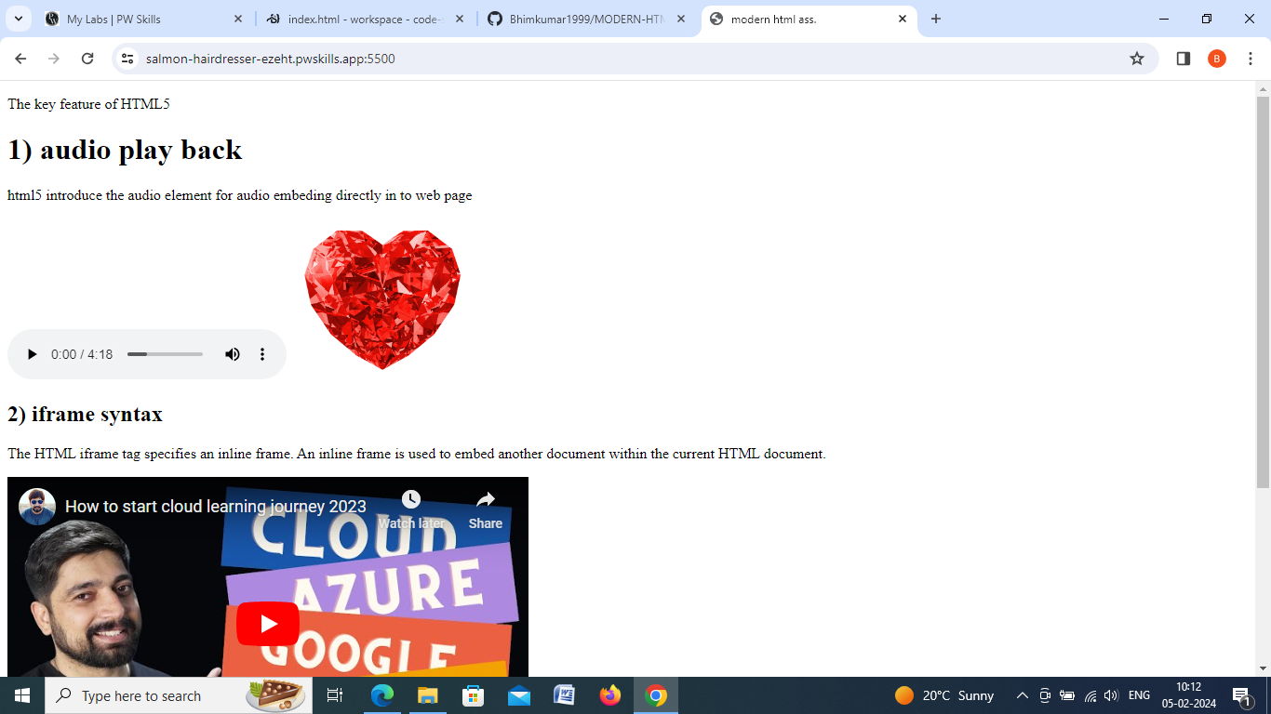

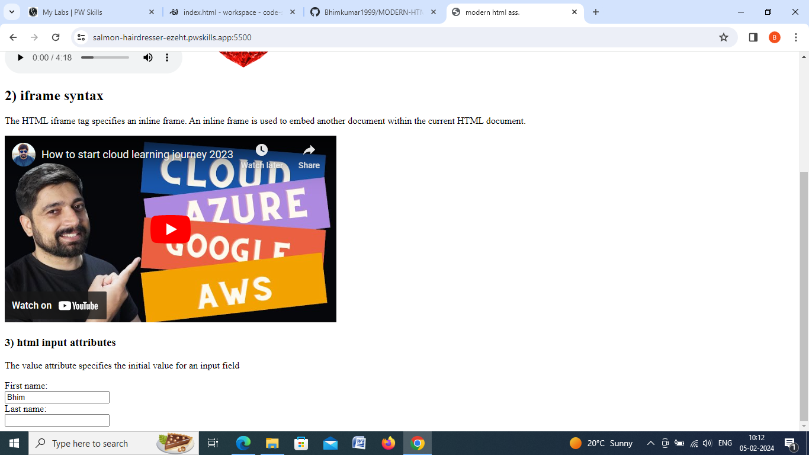

**Q6)Create a simple web page which has a table .The table must have 2 columns HTMLand HTML5. The table should include a minimum of three rows describing the difference between HTML and HTML5.**

<!DOCTYPE html>

<html lang="en">

<head>

  <meta charset="UTF-8">

  <meta http-equiv="X-UA-Compatible" content="IE=edge">

  <meta name="viewport" content="width=device-width, initial-scale=1.0">

  <title>modern html 6 ass</title>

  <style>

    table {

      font-family: arial, sans-serif;

      border-collapse: collapse;

      width: 100%;

    }

    td, th {

      border: 1px solid #dddddd;

      text-align: left;

      padding: 8px;

    }

    </style>

    </head>

</head>

<body>

  <table>

    <tr>

      <td>HTML</td>

      <td>HTML5</td>

    </tr>

    <tr><td>It didn’t support audio and video without the use of flash player support.</td>

    <td>It supports audio and video controls with the use of <audio> and <video> tags.</td>

    </tr>

    <tr><td>It uses cookies to store temporary data.</td>

    <td>It uses SQL databases and application cache to store offline data.</td></tr>

    <tr><td>Does not allow JavaScript to run in the browser.</td>

    <td>Allows JavaScript to run in the background. This is possible due to JS Web worker API in HTML5.</td></tr>

    <tr><td>It does not allow drag and drop effects.</td>

    <td>It allows drag and drop effects.</td></tr>

    <tr><td>Not possible to draw shapes like circle, rectangle, triangle etc.</td>

    <td>HTML5 allows to draw shapes like circle, rectangle, triangle etc.</td></tr>

    <tr><td>It works with all old browsers.</td>

    <td>It supported by all new browser like Firefox, Mozilla, Chrome, Safari, etc</td></tr>

    <tr><td>HTML,Body , and Head tags are mandatory while writing a HTML code.</td>

    <td>These tags can be omitted while writing HTML code.</td></tr>

    <tr><td>Doctype declaration is too long and complicated.</td>

    <td>Doctype declaration is quite simple and easy.</td></tr>

    <tr><td>Elements like nav, header were not present.</td>

    <td>New element for web structure like nav, header, footer etc.</td></tr>

  </table>

</body>

</html>

**Output:**

